SECURITY SYSTEM

Cctv

HOME CCTV PRODUCT

In Door Camera

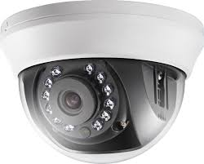

Descriptions :

HD720p,1MP CMOS Sensor, 12 pcs IR LEDs, 20m IR,

Indoor IR Dome, ICR, 0.01 Lux/F1.2, 12 VDC, Smart IR,

Wide operating temperature range (-40°~60°), 2.8/3.6/6mm Lens,

20m IR Distance, Fixed lens.

Out Door Camera.

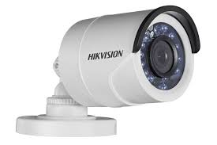

Descriptions :

HD720p,1MP CMOS Sensor, 24 pcs IR LEDs, 20m IR,

Outdoor IR Bullet, ICR, 0.01 Lux/F1.2, 12 VDC, Smart IR,

IP66, Wide operating temperature range (-40°~60°)

2.8/3.6/6mm Lens.

DVR CCTV 4/8/16 Channel.

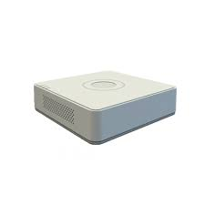

4 Turbo HD/AHD/Analog interface input, 4/8/16-ch video&1-ch audio input

1 SATA interface,1920×1080P: 12 fps/ch, 1280×720P: 25(P)/30(N) fps/ch

mini 1U case.

OFFICE AND INDUSTRY PRODUCT

In Door Camera

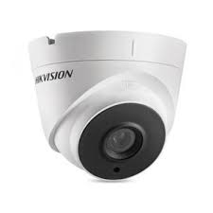

Descriptions :

HD1080p,2MP CMOS Sensor, 2 pcs EXIR LEDs

40m IR, Outdoor EXIR Eyeball, ICR, 0.1 Lux/F1.2

12 VDC, Smart IR, DNR, IP66, 3.6/6/8/12/16mm Lens.

Out Door Camera.

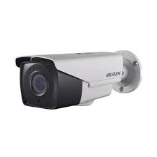

Descriptions :

HD1080p,2MP CMOS Sensor, 2 pcs EXIR LEDs

20m IR, Outdoor EXIR Bullet, ICR, 0.1 Lux/F1.2

12 VDC, Smart IR, DNR, OSD Menu(Up the Coax)

IP66, 2.8/3.6/6mm Lens.

DVR CCTV 4/8/16 Channel.

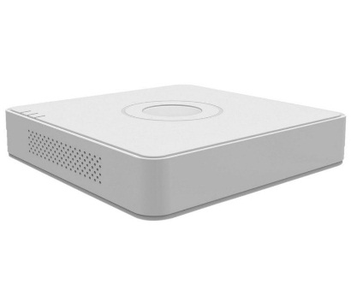

Turbo HD/AHD/Analog interface input, 4/8/16-ch video&1-ch audio input

SATA interface, 1280×720P: 25(P)/30(N) fps/ch

mini 1U case.

OFFICE AND INDUSTRY PRODUCT

TURBO HD PTZ Camera

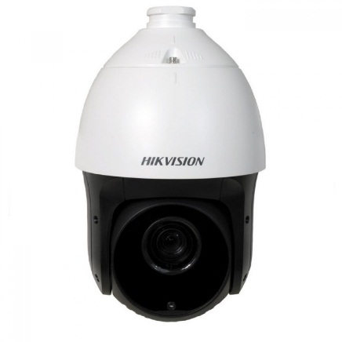

Descriptions :

1/3" CMOS, 1920x1080:30fps, TVI & CVBS dual output

3D DNR, ICR, Color: 0.05lux/F1.6, B/W:0.005lux/F1.6

Optical Zoom:23x, Focus:4.0-92mm, Digital Zoom:16X

Pan range:360° endless; Tilt range: -15°~90°(Auto Flip)

Pan Speed: 0.1° ~ 80°/s, Tilt Speed: 0.1° ~ 80°/s, Up the Coax

100m IR, 12VDC.

TRAFFIC PTZ Camera

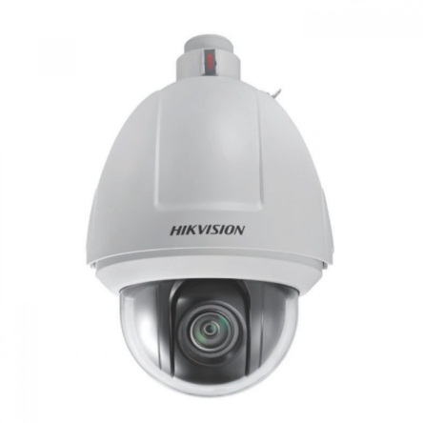

Descriptions :

1/3’’ Progressive Scan CMOS, 3D DNR, BLC,D WDR

3D intelligent positioning, 16X Optical Zoom, IP66

Pan Speed: 0.1° -250°/s, Tilt Speed: 0.1° -150°/s

PoE+&24VAC.

BANKING ATM

DVR ATM BOX

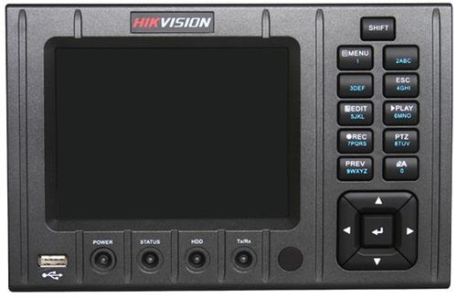

Descriptions :

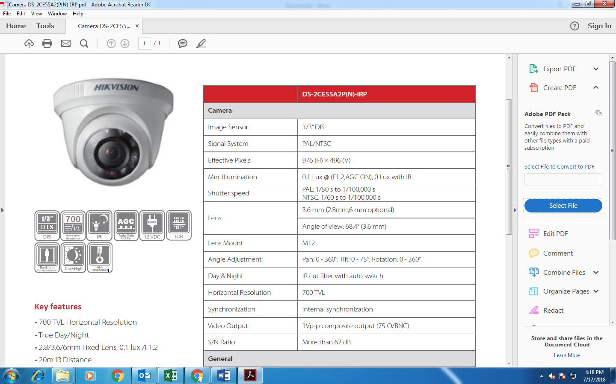4 Channel Video Input HD Camera  
Each Channel Supports up full HD and real time recording  
PRE Alarm recording  
Recovery System  
Embedded Linux OS

Camera ATM DVR BOX

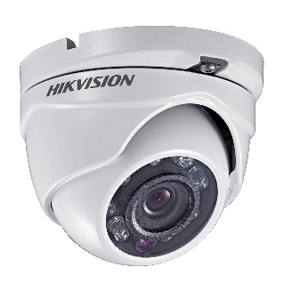

Descriptions :

HD1080p,2MP CMOS Sensor, 24 pcs LEDs, 20m IR

Outdoor IR Eyeball, ICR, 0.1 Lux/F1.2, 12 VDC, Smart IR

DNR, OSD Menu(Up the Coax), IP66, 2.8/3.6/6mm Lens

RFID Access control Terminal

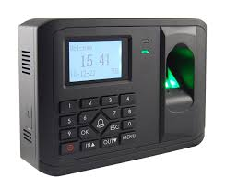

Descriptions :

LCD Display **Standalone Access Control Terminal**, Built-in EM/Mifair card reading module,   
Storage with 3,000 cards, 3,000 fingerprints and 100,000 access control events;  
Support Access Control and Time Attendance Function, Optical Fingerprint Module;  
Uplink Communication: TCP-IP, WIFI; Downlink Communication: RS485(Connect to Secure Module);  
Supports Wiegand out(W26/W34) and Wiegand in(W26/W34).  
4 colours availabe (Black, Glod, Silver and White), remark colour choices when placing order.

Villa Door Station

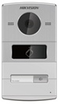

Descriptions :

1.3 MP Villa Door Station, Aluminum ally, Camera resolution: HD720P, 25fps(P)

10M/100M Self-adaptive Ethernet, RS-485, 4-ch alarm input

1-ch alarm output, IP65, 12 VDC, 1-ch Indoor station access, IR Supplement.

In Door Station

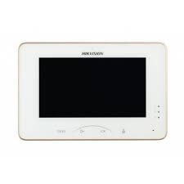

Descriptions :

**0.3MP 7“ Touch-Screen Indoor Station**, Mechanical Switch, 7-inch Colorful TFT LCD, display resolution: 1024 * 600, Camera resolution: 640 * 480, 10/100Mbps Ethernet, Wi-Fi 802.11b/g/n, 8-ch alarm input, support SD card, Power Over Network Cable/ 12 VDC